Materials

File Contains:
- Pattern Deviancy Aversion Measure in Study 1 (see 3 below for geometric shapes)
- Social Deviancy Aversion Measure in Study 1
- Pattern Deviancy Aversion Measure in Studies 2 through 6
- Social Deviancy Aversion Measure in Study 3
- Control Social Deviancy Faces Used in Studies 4, and 5
- New Pattern Deviancy Measure (NOT included in the Nature Human Behavior Paper)
- Please do not hesitate to reach out for other materials in the paper or if you have any questions: anton.gollwitzer@gmail.com

1) Study 1: Pattern Deviancy Aversion Measure

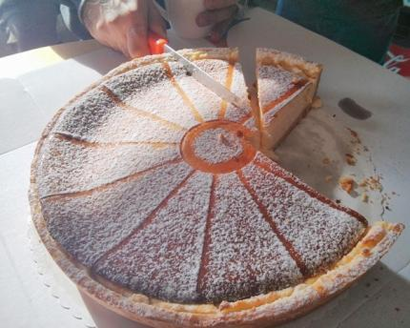

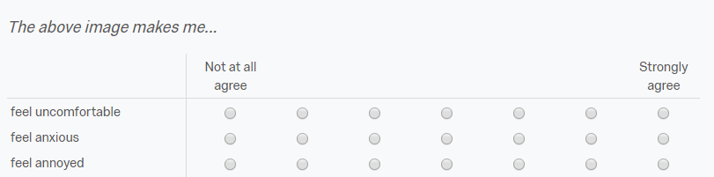

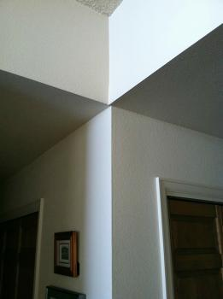

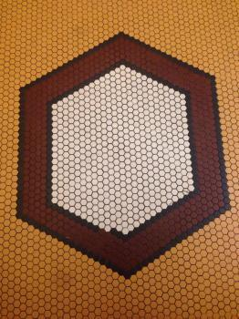

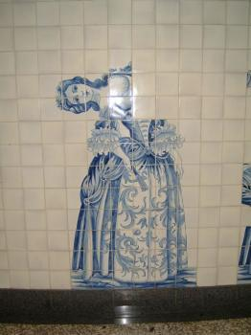

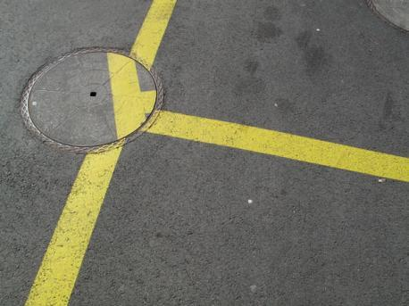

2) Study 1: Social Deviancy Aversion Measure

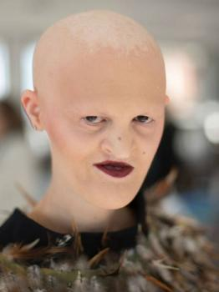

3) Studies 2 through 6: Pattern Deviancy Aversion Measure
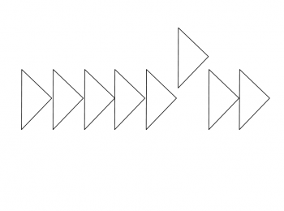

The above image makes me...
 | Not at all agree (1) | (2) | (3) | (4) | (5) | (6) | Strongly agree (7)
feel uncomfortable
feel anxious
feel annoyed

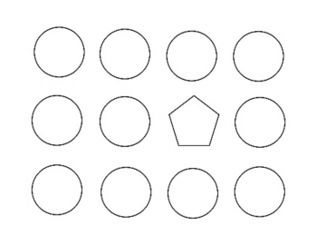

The above image makes me...
 | Not at all agree (1) | (2) | (3) | (4) | (5) | (6) | Strongly agree (7)
feel uncomfortable
feel anxious
feel annoyed

The above image makes me...
 | Not at all agree (1) | (2) | (3) | (4) | (5) | (6) | Strongly agree (7)
feel uncomfortable
feel anxious
feel annoyed

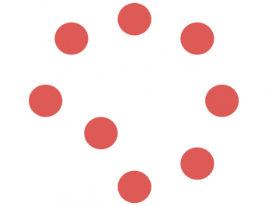

The above image makes me...
 | Not at all agree (1) | (2) | (3) | (4) | (5) | (6) | Strongly agree (7)
feel uncomfortable
feel anxious
feel annoyed

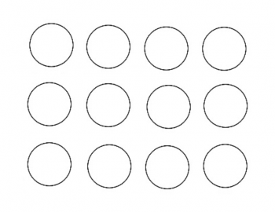

The above image makes me...
 | Not at all agree (1) | (2) | (3) | (4) | (5) | (6) | Strongly agree (7)
feel uncomfortable
feel anxious
feel annoyed

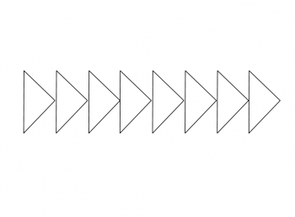

The above image makes me...
 | Not at all agree (1) | (2) | (3) | (4) | (5) | (6) | Strongly agree (7)
feel uncomfortable
feel anxious
feel annoyed

The above image makes me...
 | Not at all agree (1) | (2) | (3) | (4) | (5) | (6) | Strongly agree (7)
feel uncomfortable
feel anxious
feel annoyed

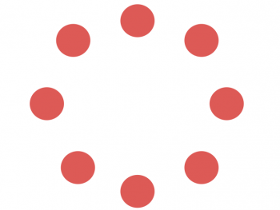

The above image makes me...
 | Not at all agree (1) | (2) | (3) | (4) | (5) | (6) | Strongly agree (7)
feel uncomfortable
feel anxious
feel annoyed

4) Study 3: Social Deviancy Aversion Measure
Please read carefully: The average annual income in the United States is around $50,000 - $60,000.

Please imagine you meet someone making $5,000 annually (remember the average annual income in the United States is around $50,000 - $60,000). How much do you agree with the following statements? 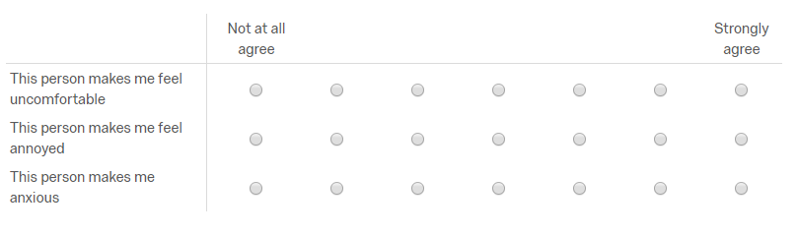

Please imagine you meet someone making around $50,000 - $60,000 annually (remember the average annual income in the United States is around $50,000 - $60,000). How much do you agree with the following statements?

Please imagine you meet someone making $500,000 annually (remember the average annual income in the United States is around $50,000 - $60,000). How much do you agree with the following statements?

Please read carefully: The average IQ in the United States ranges from 90 to 100.

Please imagine you meet someone with an IQ of 50 (remember the average IQ in the United States is around 90 - 100). How much do you agree with the following statements?

Please imagine you meet someone with an IQ of 95 (remember the average IQ in the United States is around 90 - 100). How much do you agree with the following statements?

Please imagine you meet someone with an IQ of 140 (remember the average IQ in the United States is around 90 - 100). How much do you agree with the following statements?

Please read carefully: The average weight of women in the United States is approximately 166 pounds.

Please imagine you meet a women who weighs 80 pounds (remember the average weight of a women in the United States is around 166 pounds). How much do you agree with the following statements?

Please imagine you meet a women who weighs around 166 pounds (remember the average weight of a women in the United States is around 166 pounds). How much do you agree with the following statements?

Please imagine you meet a women who weighs around 320 pounds (remember the average weight of a women in the United States is around 166 pounds). How much do you agree with the following statements?

5) Control Social Deviancy Faces Used in Studies 4 and 5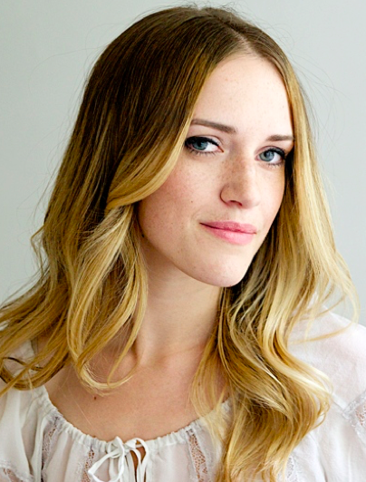
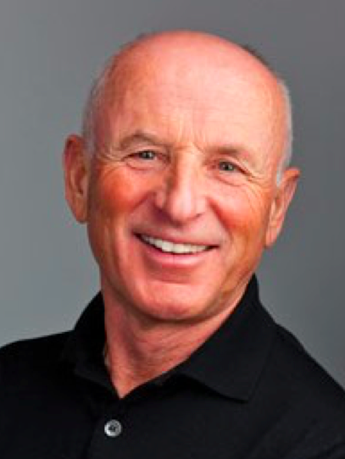

(6) New Pattern Deviancy Measure Images (NOT included in the Nature Human Behavior Paper)

Please follow this link: www.psychpopup.com/ExtraPatternDeviancyImages.zip

